**Jenkins Job Creation From Groovy DSL Scripts**

Prerequisites

* Suitable server with Jenkins version 1.62 or above installed
* All appropriate Jenkins plugins installed

Typically the Jenkins server is created utilising the ansible playbook **create_jenkins_server.yml**. This includes the installation of the plugins.

Ansible playbooks are located in this GitLab repository:

[git@git.aws.gha.kfplc.com:KITS/IS-AppSetup.git](mailto:git@git.aws.gha.kfplc.com:KITS/IS-AppSetup.git)

Creation Of Seed Job

Login to the new Jenkins environment and create a new job as follows:

Type: Freestyle project

Parameters (with defaults): String Parameter **FEATURE_NAME** = "myfeature"

String Parameter **BUILD_NUMBER** = "01"

String Parameter **ENV_PREFIX** = "${ENV_PREFIX}"

String Parameter **FITNESSE_RESULT_DIR**

= "${FITNESSE_RESULT_DIR}"

String Parameter **PIPELINE_FOLDER_NAME** = "mypipeline"

String Parameter **ATG_APP_REL_NO** = "01"

String Parameter **DB_SEED_ENV_TAKEN** = "01"

String Parameter **ATG_DB_REL_NO** = "01"

String Parameter **WMB_APP_REL_NO** = "01"

String Parameter **WMB_MOCK_REL_NO** = "01"

Build steps: One step of type ‘Process job DSLs’

Select ‘look on filesystem’ option

Put *.groovy in ‘DSL scripts’ window

Pull groovy DSL scripts from GitLab

Jenkins job DSL script files are located in the GitLab repository below:

[git@git.aws.gha.kfplc.com:KITS/Jenkins.git](mailto:git@git.aws.gha.kfplc.com:KITS/Jenkins.git)

Pull the ‘develop’ branch of this repository to a file system on the Jenkins server.

This will create a folder structure containing the scripts as per the image below. The folder structure roughly approximates the Jenkins folder structure where the jobs will be created.

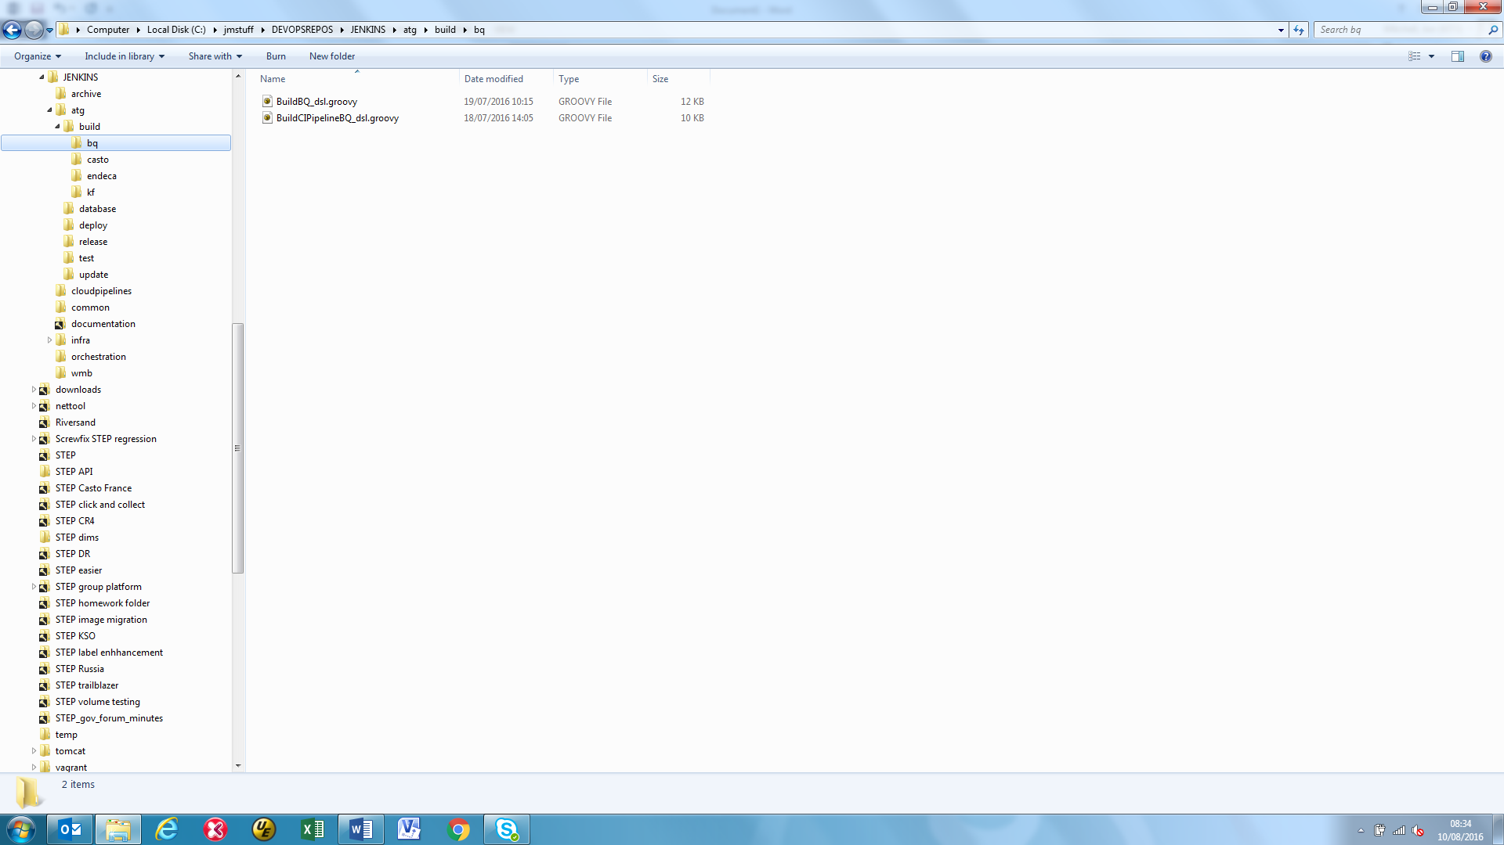

Run Seed Job Build To Create Jenkins Jobs and Folders

Copy the .groovy file(s) for the selected Jenkins folder and jobs to be created to the workspace directory of the seed job.

This directory is located at ***JENKINS_HOME/jobs/SEED_JOB_NAME/workspace***

Execute a build of the seed job.

The selected folders and jobs should then be created in Jenkins.

Repeat this process as many times as is required with the .groovy files until all jobs are created.